Detection of Stress in IT Employees Using Machine Learning Techniques

|  |  |  |
| --- | --- | --- |
|  |  |  |
|  | 1st Amritpal Kaur Dhillon  *B.E Computer Science and Engineering (Specialization in Information Security AIT-APEX)*  *Chandigarh University*  Chandigarh(Mohali), India  Dhillonamritpalcse1998@gmail.com |  |
|  |  |  |

**Summary-**The goal of this paper is to apply gadget mastering and visual processing to perceive overworked IT personnel. Our generation is an advanced model ofolder stress detection structures that-did no-longer consist-of live detection or personal counseling. stress detection methods that do not consist-of actual time monitoring or individual counseling-are being updated in this research. A survey is used to accumulate facts on personnel' mental strain tiers to provide powerful pressure control answers. To get the most from your employees, this paper will observe strain management and the way to create a healthful, spontaneous paintings surroundings**.**

**Key phrases-**Pressure Prediction, KNN Class, Facial Expressions.

1. INTRODUCTION

To be competitive, the-------------------------------------IT industry is continually launching new items and services. furthermore, employees' pressure stages have accelerated over the past 12 months, according to this ballot. The problem exists, despite the fact that many corporations provide mental health advantages to their employees. we'll begin through looking on the stress levels of employees in the place of work. pics and gadget studying may be used to take a look at strain patterns and pinpoint the most essential factors that have an effect on man or woman strain stages. according to the WHO, strain is a intellectual disease that impacts one out of each four electorate. mental and social troubles, a lack of openness in the activity, a lack of faith in coworkers, or even loss of life are only a few examples [12] [3]. Counseling is beneficial to folks who are under quite a few stresses. If we do not take precautions to govern pressure, societal and monetary structures may be affected [10]. Preventative interventions can assist to lessen the dangerous repercussions of stress. nowadays, it ambitions at offering new generation and items to the economy to offer a clean perspective. The stress stages in employees were found in the course of this take a look at, which raised the standard high [12].  
Questionnaires are robotically used inside the area of stress research to get perception into common running reports, but little is thought about the instant results of stressors at paintings [10]. There could be a hesitation on the facet of human beings to claim whether or not or now not they're worried. conventional techniques for evaluating place of work stress stages protected asking employees to fill out a survey [18]. To get the paperwork to the receiver, the sender had to installed plenty of time and effort [7]. Employers who use the stress Detection system can better put together their employees to cope with demanding activities earlier than they occur. whilst office workers are targeting their responsibilities, stress identity would possibly every so often imply distinguishing between a 'stressed' and a 'relaxed' circumstance [20]. employees' headshots are taken, and survey questionnaires are given to them which are further trendy in fashion and layout. physical exertion is decreased, which saves each time and money [27]. This organizational method can assist relieve worker strain by using the use of our painstakingly advanced questionnaire.  
the use of stress monitoring software program can improve each the nicely-being of society and the fitness of individuals. it's miles therefore important to expand clinical technologies that could examine physiological records and robotically estimate pressure tiers in human beings [21]. obesity, heart assault, diabetes, allergies, and different fitness headaches might also get up due to strain. Hourly, a student in a exclusive section of the us of a commits suicide.  
according to a Lancet document in 2012, our united states of America has seen a tremendous variety of suicide cases among younger humans aged fifteen to twenty-9 [2]. stress detection has been shown in studies to decorate people's outlook on life, that can have a extensive social gain. corporations inside the data technology quarter are currently altering the enterprise through introducing new technology and products.  
The 3 steps of photograph processing are as follows:  
gear for importing images may be used to do that. all through the method, photographs are reviewed and edited. A modified image or a record is the output of the photo evaluation. system mastering is a synthetic intelligence approach that permits a gadget to research and evolve without being explicitly programmed (AI)[5]. the development of computer programmers who can learn on their personal is the difficulty of "gadget studying," a department of laptop science [5].  
The assessment of previous work on stress detection relied on digital sign processing, which took into account Galvanic pores and skin response, blood extent, student dilation, and skin temperature [1]. different studies in this subject matter use several physiological indicators and visible traits  
(eye closure, head movement) to quantify pressure levels in individuals who're centered on their paintings [21]. these measurements, alternatively, are obtrusive and uncomfortable in actual-lifestyles programs [5][11][17]. stress is a component in as many as 50 percentage to eighty percent of all health issues, in keeping with clinical sources [1][24]. The core motive of cardiovascular disease is largely appeared to be stress. stress plays a position in some of the most common fitness issues in the United States of America. All of these problems, along with a plethora of others, are labeled as psychosomatic (i.e., brought on or amplified by way of intellectual causes which includes stress) [8]. There are 3 areas where strain has a damaging impact.  
strain can take place itself in an expansion of methods, along with feelings of guilt, embarrassment, fear, and even fury and impatience. Loneliness can manifest itself as fatigue, anxiety, challenge, infection, moodiness, and loneliness. as a result of pressure, a person's behavior alters. while people are stressed, they're much more likely to get into accidents, abuse capsules or alcohol, or have interaction in confrontational conduct. tension and stress can lower cognitive ability, reason impulsive behavior, restrict memory, and even cause hypersensitive reaction to complaint [13]. within the early tiers of despair, anxiety is not unusual. money, employment, and private relationships are just a number of the factors that could generate pressure.  
employees within the corporate world have a constrained idea of what it's like to paintings in excessive-pressure situations. lengthy-term pressure is mainly not unusual among the ones within the IT enterprise.  
Sensor technology, including smartphones and wearables with physiological and movement sensors, have been the point of interest of recent research  
[22][25].

Employees in the corporate world have a limited idea of what it's like to work in high-stress situations. Long-term stress is particularly common among those in the IT business.

Sensor technologies, such as smartphones and wearables with physiological and movement sensors, have been the focus of recent research

[22][25].

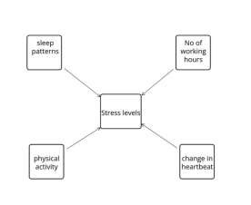

**Fig. 1**

Fig. 1 indicates the version of pressure which can be caused-by a trade in sleep patterns, physical hobby, a growth in numerous working hours, and an exchange in heart rate.

**II. LITERATURE SURVEY   
1) Detecting pressure and tension through facial clues Authors:** G. Giannakakis, et al.  
the use of video-recorded face clues, this literature assessment establishes a model for detecting and identifying strain/tension emotional states. through some form of variety of external and internal stresses, a whole experimental technique changed into designed to induce systematic diversity in emotional states (impartial, relaxed, and stressed/tense). to evaluate emotion expression more sincerely and appropriately, the paper focused mostly on non-voluntary and semi-voluntary facial cues. Sight-related sports, oral hobby, gesture popularity traits, and coronary heart price have been also tested [4].

**2)Image Processing and gadget gaining knowledge of strategies used for pressure Detection**

Authors: Nisha Raichur, et al.

A real-time non-intrusive video is produced in this paper, which detects by using reading a person's facial expression, can determine their emotional nation. every video body consists of an individual feeling, and the strain degree is determined within the hours after the video capture [18]. A mechanism is carried out that permits us each to teach a system and examine function prediction variations. The paper's findings endorse that the advanced technique works correctly with a general version of all ages [5].

**3)Techniques for Predicting Pressure in Running Personnel the Use of System Study**

**Authors: U. S. Reddy, et al.**

Gadget getting to know techniques have been applied to teach the version that have been built after preprocessing the information. It changed into measured and in comparison, to the fashions proven above to decide how well they had been synthetic [26]. Out of all the fashions boosting proved to be the most correct in our experiments. consistent with the selection bushes, factors together with gender, own family records, and the supply of fitness advantages at paintings are all elements that make contributions to strain. Many organizations now know extra about how to make their offices less demanding for his or her personnel by implementing modern technological answers [6].

**4)Analysis of Pressure Detection amongst employees using system mastering techniques**

**Authors: B. okay. Kirana Shree, et al.**

This study specializes in the usage of synthetic Neural community (ANN) classifiers to locate stress levels in employees. personnel' mental kingdom is classed by way of questions that use the Perceived pressure Scale, which also consists of their fitness and nicely-being by means of measuring cardiac fluctuation and blood strain. because an ANN classifier can examine a big number of statistics, we accept as true with it will produce an instead extra accurate solution [19] [15].

**5) Popularity of Temper at Paintings by Using Smartphones and Wearable Sensors**

Authors: Zenonos, et al.

Sensor technologies, which include smartphones and wearables with physiological and motion sensors, have been the point of interest of recent studies in this area [9]. We check out the practicality of using such devices for mood identification within the place of work in this research [14]. every two hours, a new temper detection framework that could apprehend 5 intensity levels for 8 distinctive forms of emotions is proposed. In small-scale user studies, wearable sensing data in an office is collected to assess our era surroundings. Our experiments have yielded promising effects, allowing us to correctly distinguish exceptional varieties of moods [14][16]. using sensors that degree bodily homes may be high-priced and time-talking

**6)Device Studying Paradigms for Recognizing Human Mental Stress**

Authors: Mrs. Megha V Gupta, et al.

Detection of human intellectual pressure utilizing machine mastering frameworks and methodologies which includes Electroencephalogram (EEG), Speech sign, and audio-visible facts. For strain detection using EEG, the Database for Emotion evaluation the use of  
Physiological indicators (DEAP) dataset may be used. using Speech alerts and audio-visual information, RAVDESS (Ryerson Audio-visual statistics of Emotional Voice and song) can also be designed to recognize stress [18].

**7**)**Pressure and Relaxation Magnitudes for Tweets Detection**

Authors: Reshmi Gopalakrishna Pillai, et al.

On this exploration work, a WSD association as a preprocessing level to a cutting-edge vocabulary-based totally stress/unwinding strategy. A dataset concerning one thousand tweets with questionable have an effect on words become collected and commented on with excessive inter-annotator know-how. becoming a member of a WSD became discovered to essentially paintings at the presentation of TensiStrength concerning Pearson's connection and exact suit charge, for each strain and unwinding. TensiStrength with WSD outflanks AI strategies additionally. Given the reasonably small length of the take a look at set, this should be additionally concentrated on using greater datasets defined with pressure and unwinding traits [7].

**8)Detecting pressure, the usage of Social Interactions**

Authors: Huijie Lin, et al.

In this paper, a creation for perceiving clients' mental anxiety states from customers' step-by way of-step net-based diversion facts, the usage of tweets' substance in addition to clients' socially coordinated efforts. using real virtual diversion records because the purpose, we centered on the relationship amongst purchaser' mental tension states and their social affiliation strategies to performing. We developed a crossbreed model that mixes the element diagram model (FGM) with a convolutional frontal cortex affiliation to absolutely take advantage of each substance and social joint exertion statistics from customers' tweets (CNN) [8].

**III. PROPOSED METHOD**

strain is assessed the use of supervised system gaining knowledge of algorithms inclusive of KNN classifiers within the proposed system. The detection of pressure is finished via photograph processing. The worker's image is given through the program as statistics, and picture Processing is applied for discovery on the underlying degree. with the aid of translating a photograph to digital shape and appearing operations on it, image processing can enhance or extract relevant records from it. In previous papers, diverse gadget studying algorithms have been used like SVM, linear regression, logistic regression, and many others., however didn’t use KNN for the experiment that's similar to our method. not only accuracy however we additionally determined classification errors, Sensitivity, specificity, false fine price error, and precision. Our machine is an up-to-date version of earlier stress detection structures that did now not consist of stay analysis or man or woman counseling, however it now incorporates live monitoring and frequent worker evaluation, in addition to identifying physical and emotional strain degrees. because there may be no non-stop taking of pix, it takes much less time and produces greater powerful effects while as compared with the consequences achieved by way of constantly capturing pix of someone.  
by taking a photo as enter and returning a picture or traits associated with those pictures as output. We use a bounded box to expose the employee's feelings, and additionally the emotions are proven at the pinnacle of the bounded box. irritated, Disgusted, frightened, sad, and neutral are all strain signs.

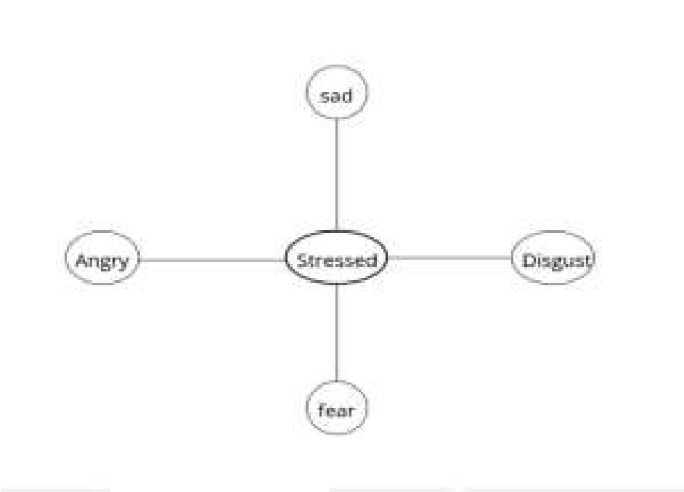

**Fig. 2. Indication of harassed feelings states.**

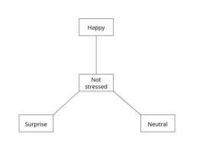

**Fig. 3. Indication of not stressed feelings states.**

1. **Benefits of this approach**

**•**An image that has been edited or a report based on photo analysis because of the-output.  
•The pressure Detection device helps workers in dealingwith problems that add to pressure via giving proactive pressure control solutions.  
•Over-periodic instances, we will take pictures of personnel after which distribute traditional survey paperwork to-them.  
•We can-also use-a stay cam to locate the stress of-the worker, which suggests the pressure function of a person. algorithm: k-Nearest Neighbor (KNN)

**Dataset:**

To complete the task according with predictions or judgments, an express mathematical model is developed the use of "education facts". photograph mining may be used to discover hidden data in snap shots, hyperlink formerly unrelated facts, and find new styles in the information being mined. The dataset carries a grid illustration of an existing dataset with extraordinary traits. characteristic selection is the technique worried in diminishing the wide variety of data factors even as fostering a prescient version. it is the method of choosing suitable traits in your classification set of rules that relies upon at the form of difficulty you're attempting to reply automatically. but property Extraction produces a very redesigned dataset with most effective mathematical enter parameters as an outcome of primary component evaluation feature choice, which transforms into six important additives: condition (No stress, Time pressure, Interruption), stress, bodily demand, performance, and Frustration.

***angry:***



***Disgusted:***



***fearful:***



***glad:***



***impartial:***



***unhappy:***



***amazed:***



**IV. Algorithm**

**The subsequent is a trendy description of ways the proposed system set of rules works:**

Step 1: begin Step 2: employee Login.  
Step 3: determine whether or not the IT employee is currently employed.  
Step 4: If you have not already, sign on.  
Step 5: go back to the previous step. Step 6: If the solution is yes, the worker will log in.  
Step 7: add the image.  
Step 8: If the uploaded image is not in JPG file layout, then a message” THIS is not A JPG  
document” is displayed.  
Step 9: If the uploaded image document format is legitimate then the photograph is detected.  
Step 10: user live Cam Detection.  
Step eleven: KNN set of rules effects are acquired  
along with type errors, sensitivity,  
specificity, consider, precision, Step 12: stop.

**A. Implementation of KNN**

• System mastering is basically divided into three classes: Supervised mastering, Unsupervised getting to know, and reinforcement mastering. We chose the KNN algorithm amongst all of the gadget gaining knowledge of algorithms as it saves every piece of statistics and makes use of it to classify new information.  
• In this, no assumptions are made approximately the records.  
• It saves the dataset at some stage in schooling and then acts on the dataset.  
• The ok Nearest acquaintances' primary premise is that the statistics points with the shortest characteristic area distance from our new records point are called nearest friends.  
• okay is the sum of all such information points we recall in the course of the implementation of our category algorithm.  
• We iterate the-KNN method with various k values till we find one that significantly minimizes the range of errors at the same time as retaining the algorithm's potential to make right predictions when given statistics it hasn't visible before.  
• In this it finds the minimal distance among the brand new records and the facts points within the characteristic area. on this paper, the cost of k is 5 and the space is observed through the use of the most popular distance metric known as Euclidean distance.  
• The space can rather be calculated the use of Hamming, Manhattan, or Minkowski distances, relying on the desires.  
• The gap is calculated between the new information point and the existing statistics points and takes the five nearest factors to the information point.  
• The brand new facts factor will cross into the category that has most nearest acquaintances.

**V. EXPERIMENTS AND evaluation**

To test the efficiency of the stability, we amassed statistics and carried out a quantitative experimental investigation.  
first off, the user has to sign in with the specified details person name, login identification, password, cell, e mail, Locality, address, town, and kingdom. with all the required information user has to check in. If all the information is correct then the message could be displayed as “you have been successfully registered”. Password ought to include one quantity, one top case, and lowercase letters and should contain eight characters or extra. in case you input an e mail or mobile quantity that already exists it will display a message as “e mail or cellular already existed”. If any of the fields is missed then it'll show a message as “Please fill out this subject”. If a lot of these information are entered, then simplest consumer registration can be a success.

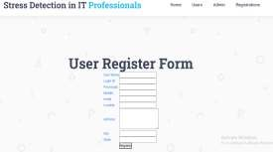

**Fig. 4. user Registration form**

consumer Registration isneeded to understand whether the employee is presently hired via that IT agency or now not and for protection and privateness purposes as well. If the man or woman is an introvert or some sort of character who has having inferiority complicated is not interested in exposing his/her strain to others and additionally now not relaxed sharing personal details like images, usernames, passwords, and many others.



**Fig. 5. Admin login shape**

Admin has to login by means of “admin” as both consumer call and password. After admin a success login-he

can prompt the efficiently registered user.

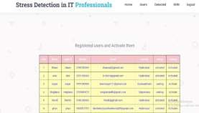

**Fig. 6. Admin customers internet web page**

Users can log in with a registered Login identity and password. He can efficiently log in most effective if the admin activates that consumer. If the admin does no longer set off that consumer, then he cannot log in and the message will be displayed as “your account no longer but activated”.

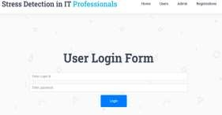

**Fig. 7. user login form**

If the person efficiently logs in, then a page might be opened-that consists of domestic, picture, stay Cam, KNN, and Logout pages.

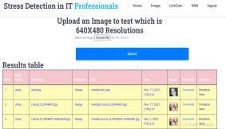

**Fig.8. user photograph web page**

If the person clicks on the photo page, then the person can upload the photograph and spot the effects. users can also see already uploaded pics and their effects as properly. As this shops formerly uploaded photos, this will assist for future medical references through which a psychiatrist can be able to assist the person. not most effective the unmarried face but this technique also can detect the more than one faces as nicely.

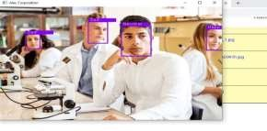

**Fig. 9. Uploaded photograph Facial feelings**

If the person clicks at the live cam, then the digital camera activates and video display units the face of a person who is in the front of the camera and displays the result. It additionally monitors more than one faces as properly.

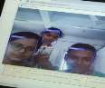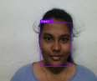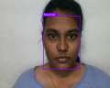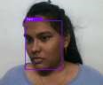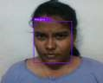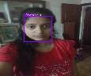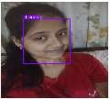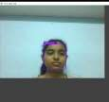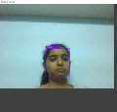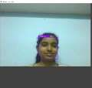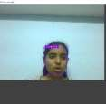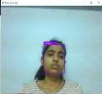

**Fig. 10. the usage of live Cam end result**

After importing the image or when the usage of the stay Cam, the result could be displayed at the top of the bounding container.  
If the user clicks on the KNN web page then the user can see the  
Accuracy is received the usage of the KNN algorithm.  
in conjunction with accuracy user can also see class blunders, Sensitivity, specificity, fake high quality charge blunders, and precision.  
category mistakes implies how often is the classifier proper. Sensitivity implies whilst the actual fee is tremendous, how frequently is the prediction right? Specificity implies whilst the actual cost is bad, how frequently prediction is proper?  
A false advantageous fee implies while the real fee is poor, how often prediction is the wrong? Precision implies whilst a high-quality value is expected, how often is the prediction right?

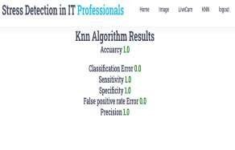**Fig. 11. KNN algorithm result**

Through clicking at the logout page consumer returns to the house web page.

**VI. End/Conclusion**

The stress Detection device is designed to assess worker stress by using reviewing snap shots submitted with the aid of tested users, making the framework reliable. After a hit registration and login, the person uploads the photo and also uses the stay cam. After importing the image, we can get the output of the stress level on the pinnacle of the bounded field as angry, unhappy, satisfied, disgusting, and impartial.  
We broaden this version by means of the use of a gadget getting to know algorithm like the KNN classifier. We use the KNN classifier and predict the accuracy of the version. alongside the accuracy we additionally predict class blunders, sensitivity, specificity, false high-quality rate error, and precision. we will supply a success answer for pressure management, preserving the running conditions sound and unconstrained for representatives, and capitalizing on them for the duration of work hours, thusly.

**VII. Future SCOPE**

To discover pressure, the proposed method combines photo processing and deep gaining knowledge of. To extract features, images have been accrued and analyzed. at the side of the live Cam, the video facility can also benefit destiny work with various algorithms. The set of rules processing outputs were used to educate the version and test it with the test dataset. despite the fact that the received outcomes are initial due to the small variety of humans worried or technical records, the key brought price of this paper is received via permitting end-customers to correctly recognize ongoing pressure to decrease future fitness risk elements. A broader population study could be part of our destiny attempt.

**VIII.REFERENCES**

[1] Widanti, N., Sumanto, B., Rosa, P., Miftahudin, M.F.. strain stage detection the usage of heart fee, blood stress, and GSR and stress therapy via using infrared. In: industrial Instrumentation and manage (ICIC), 2017 international convention on. IEEE; 2017.  
[2] Ravinder Ahujaa, Alisha Bangab “intellectual strain Detection in college students the usage of device gaining knowledge of Algorithms”, worldwide convention on Pervasive Computing Advances and programs,2019.  
[3] Sharma, L.D., Bohat, V.okay., Habib, M. “pressure Detection  
the use of EEG alerts”, journal of advanced research in Dynamical and manipulate structures,2017.  
[4] G. Giannakakis, D. Manousos, F. Chiarugi, “stress and anxiety detection the use of facial expressions from films,” Biomedical signal Processing and manipulate”, vol. 31, pp. 89- 101, January 2017.  
[5] Nisha Raichur, Nidhi Lonakadi, Priyanka Mural, “Detection of strain the usage of picture Processing and gadget mastering strategies”, vol.nine, no. 3S, July 2017.  
[6] U. S. Reddy, A. V. Thota and A. Dharun, "machine learning techniques for pressure Prediction in working employees," 2018 IEEE worldwide conference on Computational Intelligence and Computing studies (ICCIC), Madurai, India, 2018.  
[7] Reshmi Gopalakrishna Pillai, Mike Thelwall, Constantin Orasan, “Detection of pressure and rest Magnitudes for  
Tweets”, international global huge internet conference Committee ACM, 2018.  
[8] Huijie Lin, Jia, JiezhonQiu, “Detecting pressure based totally on social interactions in social networks”, IEEE Transactions on expertise and facts Engineering, 2017.  
[9] Enrique Garcia-Ceja, Venet Osmani and Oscar Mayora,  
“automatic strain Detection in working environments from Smartphones’ accelerometer facts: a first Step”, arXiv:1510.04221v1 [cs.HC] 14 Oct 2015.  
[10] Saskia Koldijk, Mark A. Neerincx, and Wessel Kraaij, “Detecting paintings pressure in workplaces with the aid of combining unobtrusive sensors”, IEEE Transactions on affective computing 2018. [11] Virginia Sandulescu, Sally Andrews, David Ellis, “pressure Detection the use of wearable physiological sensors”, Springer global Publishing Switzerland 2015.  
[12] Ankita Patil, Rucha Mangalekar, Nikita Kupawdekar, Viraj Chavan, Sanket Patil, and Ajinkya Yadav, “strain Detection in IT experts through picture Processing and machine getting to know,” worldwide journal of studies in Engineering, technological know-how and control, Vol.  
three, No.1, January-2020.  
[13] B. Padmaja, V. V. Rama Prasad, and ok. V. N. Sunitha, “A gadget gaining knowledge of method for stress  
Detection the usage of a wireless physical interest Tracker,” global magazine of system learning and Computing, February, Vol. eight, No. 1, February 2018.  
[14] Zenonos, A., Khan, A., Kalogridis, G., Vatsikas, S., Lewis,  
T., Sooriyabandara, “wholesome office: mood popularity at paintings the usage of smartphones and wearable sensors”, IEEE global convention on Pervasive Computing and communique Workshops 2016.  
[15] Tanev, G., Saadi, D.B., Hoppe, k., Sorensen, H.B “classification of acute strain the use of linear and non-linear coronary heart charge variability analysis derived from sternal ECG” 2014 thirty sixth Annual international conference of the IEEE Engineering in medication and Biology Society.  
[16] Deng, Y., Wu, Z., Chu, C.H., Zhang, Q., Hsu, D.F. Sensor characteristic selection and aggregate for stress identity using combinatorial fusion. global magazine of superior robotic structures 2013.  
[17] Ghaderi, A., Frounchi, J., Farnam, A. gadget studying-based totally sign processing the use of physiological indicators for pressure detection. In: 2015 twenty second Iranian conference on Biomedical Engineering (ICBME). 2015.  
[18] Mrs. Megha V Gupta Dr. Shubhangi Vaikole “popularity of Human mental strain the usage of gadget studying Paradigms”,2020.  
[19] Liu, D., Ulrich, M. listen in your coronary heart: stress prediction the use of patron heart rate sensors 2015.  
[20] Nakashima, Y., Kim, J., Flutura, S., Seidler, A., Andre, E. pressure popularity in each day paintings. In: ´ global Symposium on Pervasive Computing Paradigms for intellectual health. Springer; 2015.  
[21] Xu, Q., Nwe, T.L., Guan, C. Cluster-based evaluation for personalized strain assessment the usage of physiological indicators. IEEE journal of biomedical and fitness informatics 2015. [22] Gjoreski, M., Gjoreski, H., Lustrek, M., Gams, M. non-stop pressure detection the usage of a wrist device: in laboratory and actual life. In: lawsuits of the 2016 ACM global Joint conference on www.jespublication.com Pervasive and Ubiquitous Computing: Adjunct. ACM; 2016.  
[23] Palanisamy, ok., Murugappan, M., Yaacob, S. multiple physiological sign-based human pressure identification using non-linear classifiers. Elektronika ir elektrotechnika 2015. [24] Villarejo, M.V., Zapirain, B.G., Zorrilla, A.M. A strain sensor primarily based on galvanic pores and skin response (GSR) controlled by using ZigBee. Sensors,2012.  
[25] Selvaraj, N. mental acute pressure measurement using a wireless adhesive biosensor. In: 2015 thirty seventh Annual international conference of the IEEE Engineering in medicine and Biology Society (EMBC), 2015.  
[26] Sriramprakash.S, Prasanna Vadana. D, O. V. Ramana  
Murthy “strain Detection in operating people” seventh global  
convention On Advances in Computing & Communications,  
ICACC 2017, August 22-24, 2017.  
[27] Koldijk, S., Neerincx, M.A., Kraaij, W. Detecting paintings stress in offices by way of combining unobtrusive sensors. IEEE Transactions on Affective Computing 2016.